**Administrative Information**

* ***Hotel Accommodation***

龙湖假日酒店地址：烟台市牟平区滨海东路653号烟台龙湖葡醍商业街10-10号楼 龙湖假日酒店

Building 10-10, Longfor Street., No.653, East BinHai Road, MuPing District, Yantai, Shandong, China.

Tel : 0535-3398777

Fax：0535-3398100

# Participants are requested to settle their personal incidentals at the hotel prior to their departure upon check-out. Complimentary breakfast is included in the package. Check-in time is at 12:00 and check-out time is at 12:00. Late check-outs are to be settled by the participant.

Late check-out till 18:00: 50 % of one-day rate

Late check-out after 18:00: 100% of one-day rate

* ***Registration***

There will be a reception desk of NSD at the conference venue **in the morning of June 26**, our staff will help you do the registration and distribute conference materials.

* ***Transportation***

We will arrange airport pick-up for keynote speakers if you need. In case you want to come by yourself, you may need the following information:

**Getting to the Longfor Hotel from the airport by taxi**

Costs: about 220 RMB (approx. 35USD). Duration of trip: 60 minutes.

As many taxi drivers do not speak English very well it is a good idea to show them the address in writing:

**请送我去龙湖假日酒店 (“Please drive me to the Longfor Hotel.”)**

**地址：烟台市牟平区滨海东路653号烟台龙湖葡醍商业街10-10号楼**

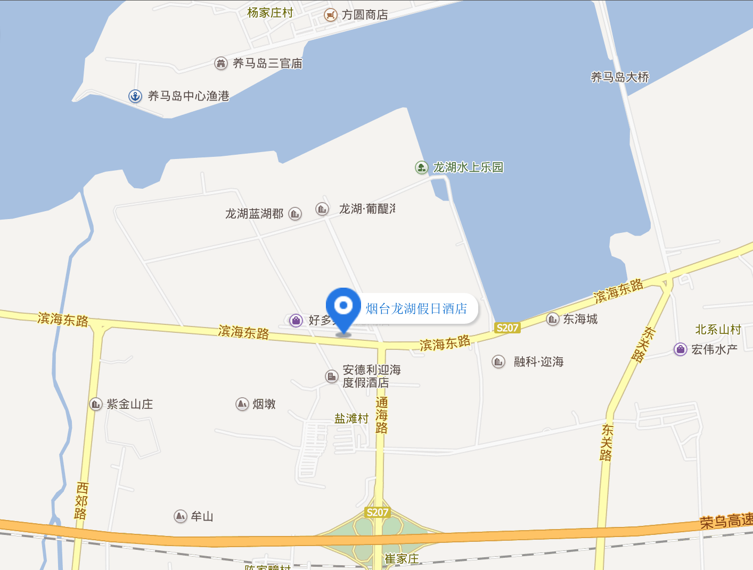

* ***Meals***

Complimentary breakfast is included in the hotel reservation. Lunch and Dinner will be provided by CCER.

* ***Local Contact***

**Dr. Xiaoyan Lei**

Associate Professor, National School of Development

Peking University

Tel: +86-10- 62758946

Email: xylei@nsd.pku.edu.cn

**Ms. Dian Cheng**

Project Coordinator

Tel: +86-15210513563

Email: dcheng@nsd.pku.edu.cn

**Ms. Xiaowen Hu**

Secretary on Foreign Affairs

Tel: +86-13661236529

Email: xwhu@nsd.pku.edu.cn